Chapter 14, Problem 62.

The filter in Fig. 14.90(b) has a 3-dB cutoff frequency at 1 kHz. If its input is connected to a 120-mV variable frequency signal, find the output voltage at:

(a) 200 Hz (b) 2 kHz (c) 10 kHz

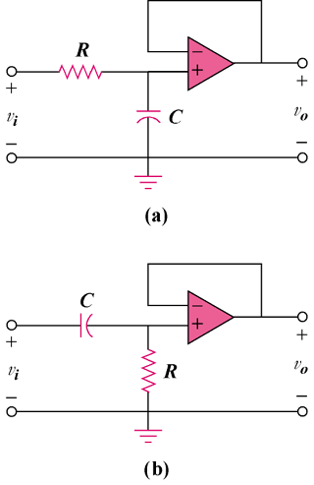

Figure 14.90
For Prob. 14.62.

